GGL System report

(<http://ggl.neotural.com/login>)

1. Admin – Approval booking – Please for information Approval Booking adjusted by information booking details (sort by category)

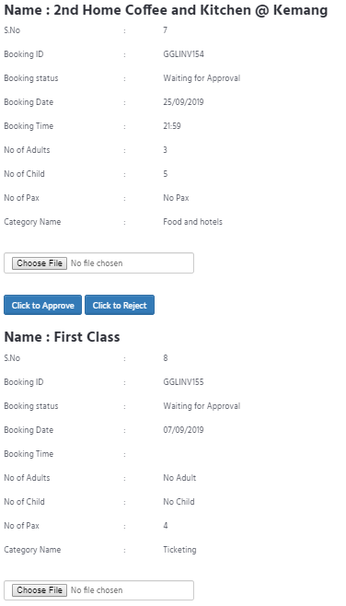

2. [www.gglway.com](http://www.gglway.com) – Contact – Please add for receive an any Message in GGL to email : globalgains49@gmail.com - cannot click send

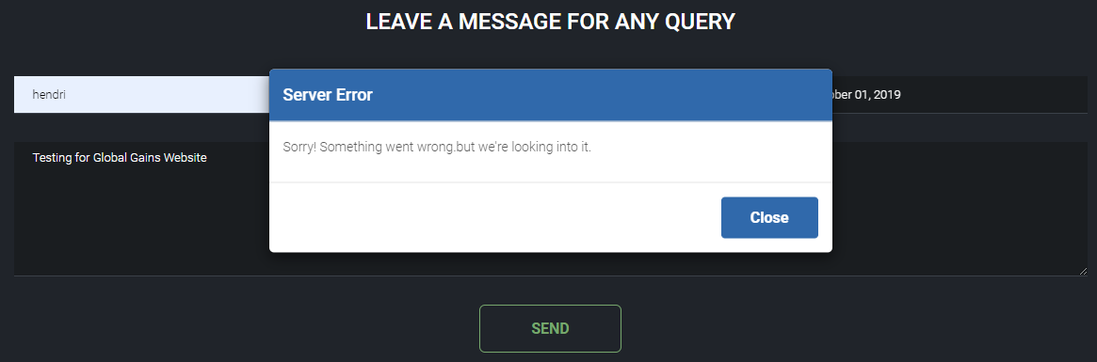

3. Member – Email – Not get email notification if Unit Status is Close - Please add for member and admin (admin must know if Status is Close)

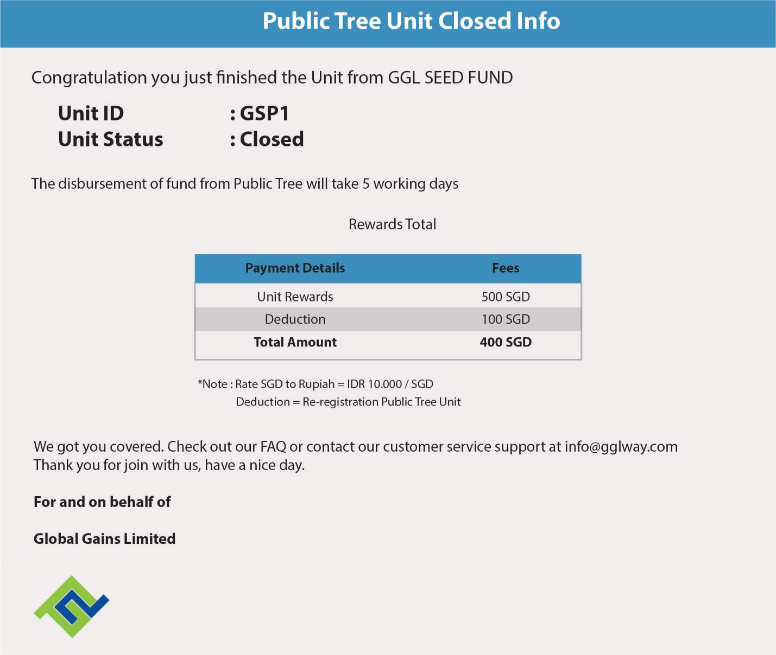

4. Email - Member – Investment – Purchase Unit – Notification Invoice on email (please change like this picture) - *note : please adjust member name, invoice number, and total amount on invoice

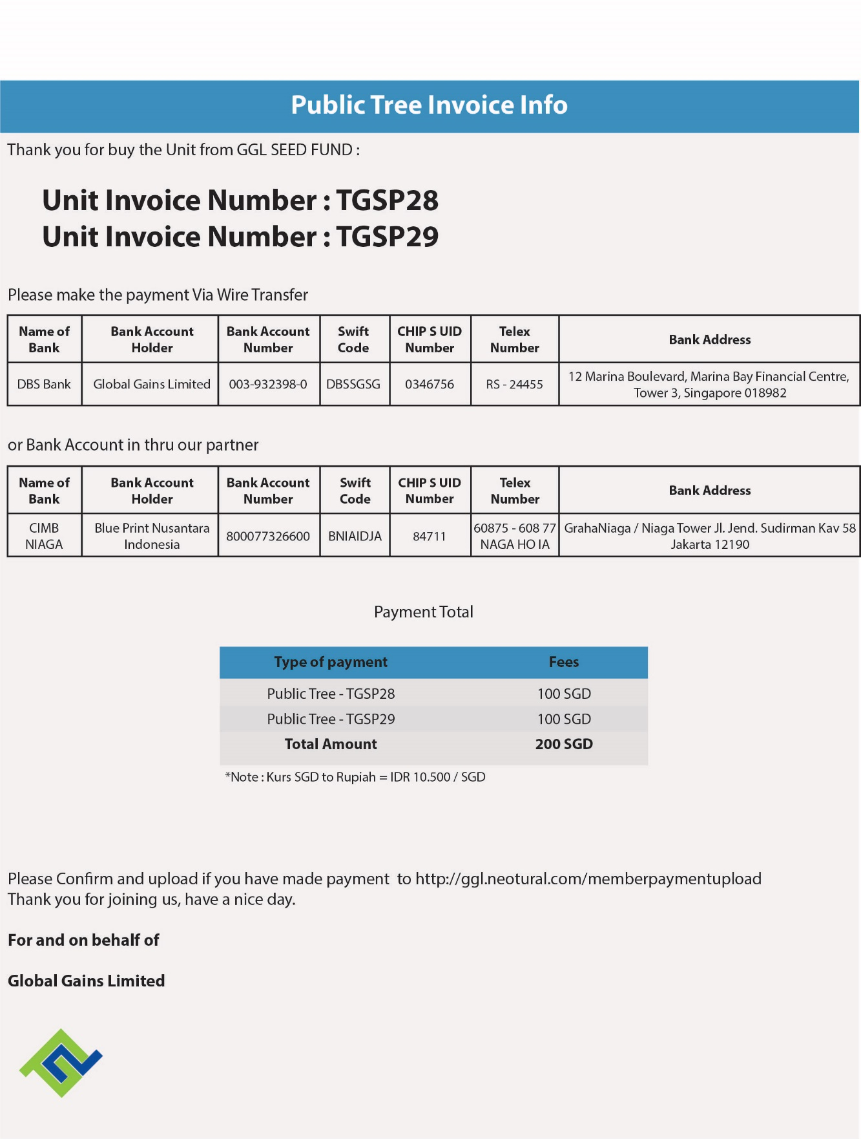

5. Email – new member notification – please give space for speeling ( the deposits, deposit slip, the original, full responsibilities)

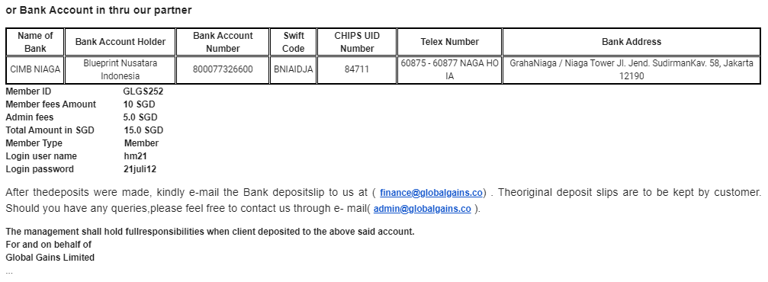

6. All of System – Not get notification on email

7. Member – Home – Please Adjust Member Name (not Mr. Xander)

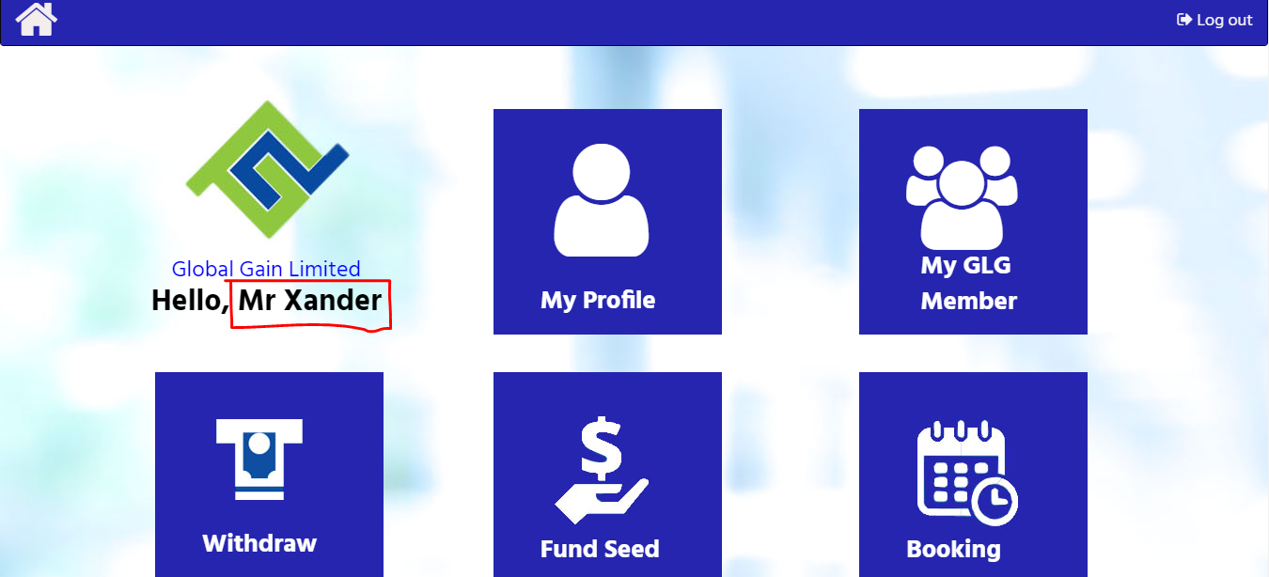

8. Member – My Profile – For the Red Square please adjust by Design

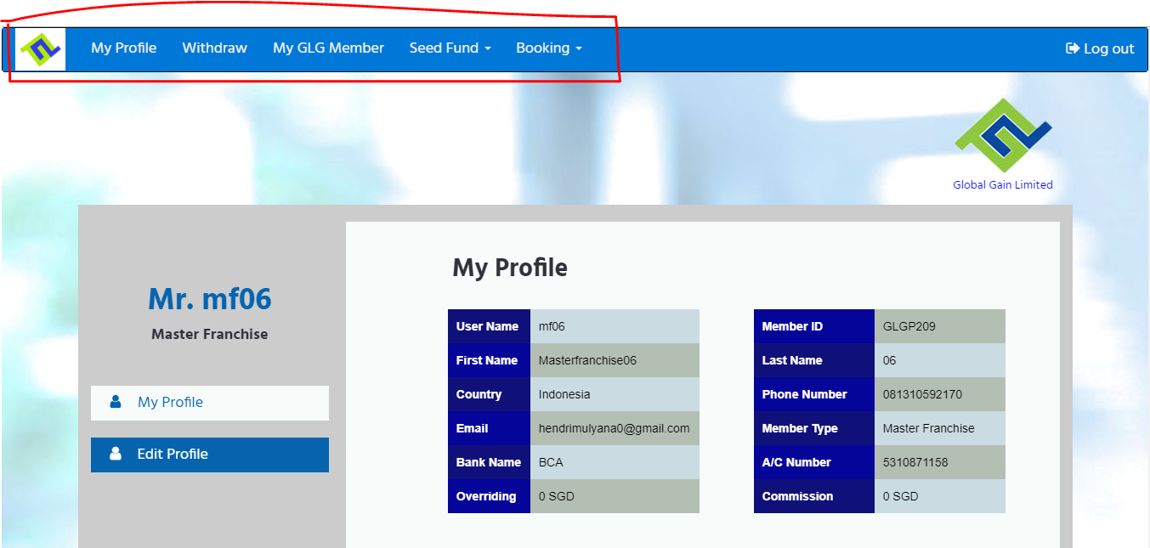

9. Member – My GLG Member - For the Red Square please adjust by Design

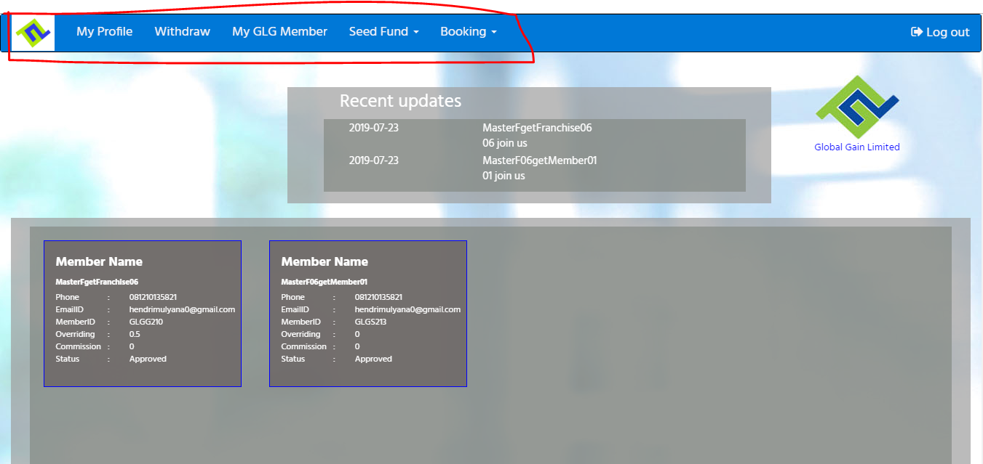

10. Member – Withdraw - For the Red Square please adjust by Design

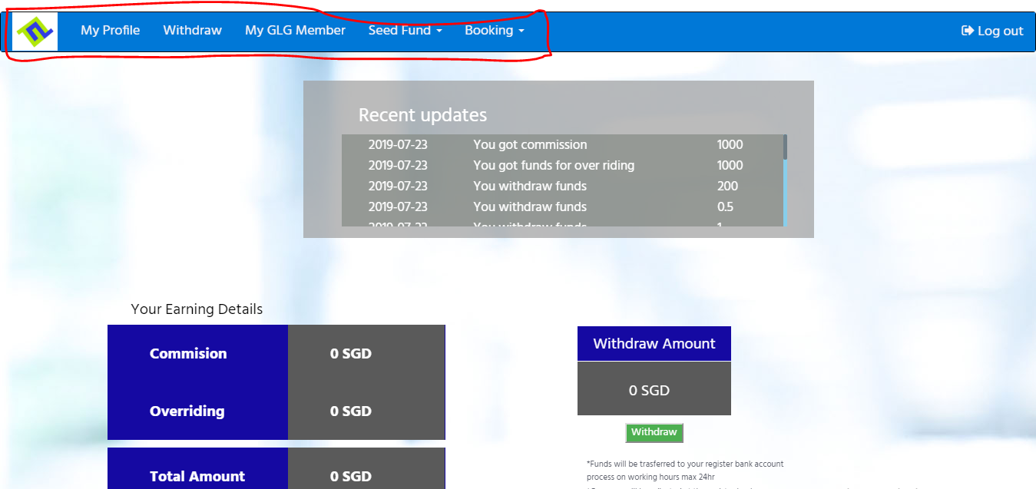

11. Member – Fund Seed – Please Adjust by Design (All pages adjust by design)

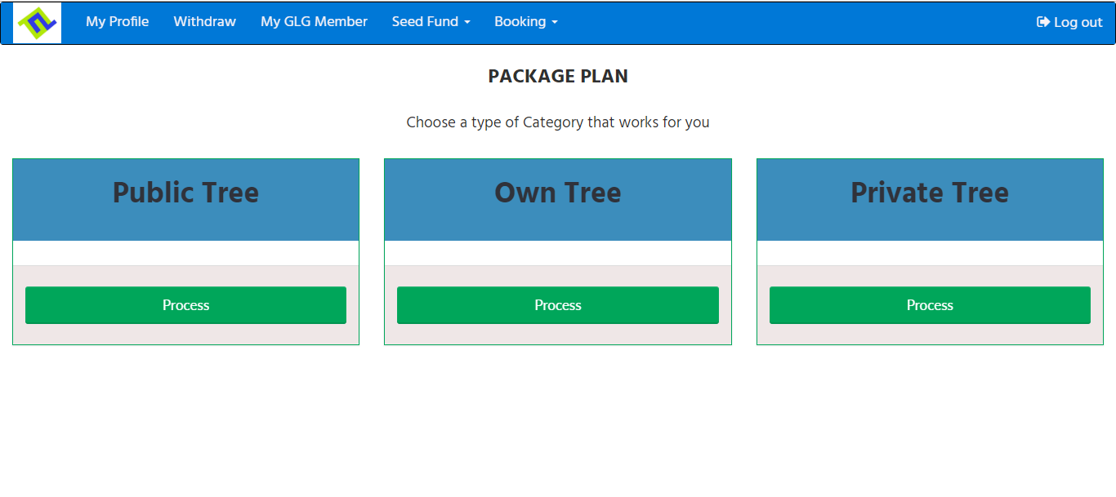

12. Member – booking – for the red square Please adjust by design

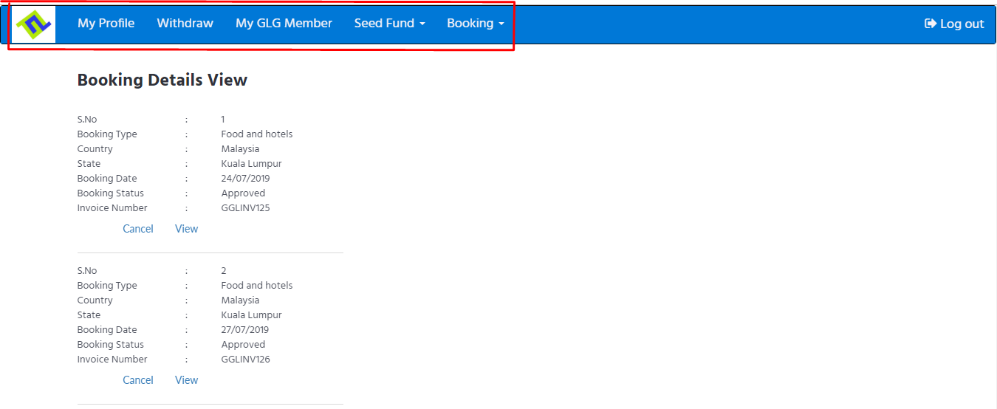

GGL Mobile Apps report

1. Member – Withdrawl – Cannot Click Withdrawl

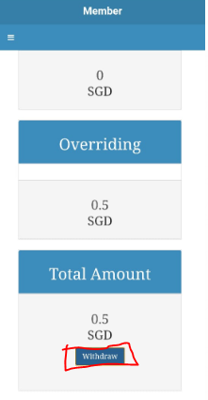

2. Member – Investment – Please change name INVESTMENT to FUND SEED

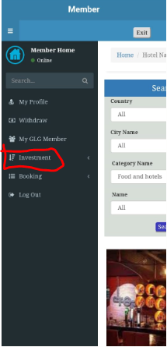

3. Member – Investment – Payment Option – Online Payment – Cannot Continue to Checkout

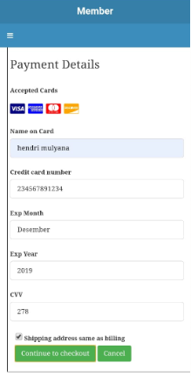

3. Member – Investment – Payment Option – Wire Payment – Please for bank account details entered into the wire transfer column ( Change Name Account Holder to Blueprint Nusantara Indonesia)

